**Azure Architecture for a High-Performance and Resilient Web Service**

**1. Introduction**

This document outlines the proposed Azure architecture for a web service designed to handle 1000 requests per second (RPS), integrate with external services, and prioritize security, high availability, and fault tolerance.

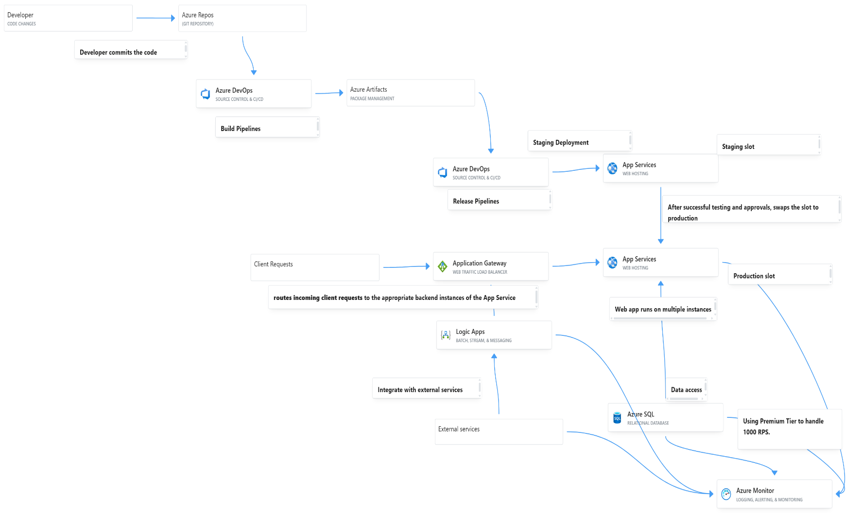**2. Architecture Diagram**

**3. Component Explanation**

* **Ingress** 
  + **Azure Application Gateway:** Layer 7 load balancer with Web Application Firewall (WAF) for routing and security.
* **Compute** 
  + **Azure App Service:** Platform for hosting the web application, scaled for high RPS.
* **Data** 
  + **Azure SQL Database (Premium):** Relational database optimized for performance and availability.
* **Integration** 
  + **Azure Logic Apps:** Serverless workflow orchestration for complex integrations.
* **CI/CD** 
  + **Azure Repos:** Git repository for source code management.
  + **Azure DevOps (Build):** Automated build and testing of the application.
  + **Azure Artifacts:** Storage for build outputs (artifacts).
  + **Azure DevOps (Release):** Automated deployment to different environments.
  + **App Service Staging Slot:** Temporary environment for pre-production testing.
  + **App Service Production Slot:** Live environment serving user traffic.
* **Monitoring** 
  + **Azure Monitor:** Comprehensive monitoring and logging for all services.

**4. Deployment and Release Plan**

* **CI/CD Pipeline:** 
  + **Build Pipeline:** 
    - **Trigger:** Code commits to main branch.
    - **Tasks:** Build, test, package application.
  + **Release Pipeline:** 
    - **Trigger:** Successful build.
    - **Stages:** Staging, Production (with manual approval).
    - **Deployment:** Slot swapping for zero-downtime deployments.
* **Release Strategy:** 
  + Zero-downtime deployments using App Service slots.
  + Automated rollback by swapping slots in case of failure.

**5. Security Considerations**

* Azure Application Gateway (WAF): Protects against web exploits (OWASP Top 10).
* HTTPS: Enforces secure communication.
* Managed Identities: Secure access to Azure resources (SQL, Key Vault).
* Network Security Groups (NSGs): Restricts network traffic to resources.
* Azure Defender for Cloud: Threat detection for App Service and SQL Database.

**6. High Availability and Fault Tolerance**

* Azure App Service (Multiple Instances): Provides redundancy and scalability.
* Azure Application Gateway: Distributes traffic and ensures health checks.
* Azure SQL Database (Premium): Offers built-in high availability.
* App Service Deployment Slots: Enables zero-downtime deployments and rollback.
* Retry Logic (App Service/Logic Apps): Handles transient errors during external service calls.

**7. Integration with External Services**

* Azure Logic Apps: Orchestrates workflows to connect to external APIs and services.
* HTTPS: Secure protocol for API communication.
* Azure Service Bus (Optional): Asynchronous messaging for decoupled integrations.

**8. Monitoring and Alerting**

* Azure Monitor: Collects and analyzes logs and metrics from all services.
* Application Insights: Provides detailed application performance monitoring.
* Alerts: Configured for critical performance and error conditions.

**9. Scalability**

* Azure App Service: Auto-scales based on traffic load.
* Azure SQL Database: Scales up to handle increased data throughput.
* Azure Logic Apps/Functions: Serverless and automatically scale.

**10. Conclusion**

The proposed Azure architecture and implementation plan effectively address the requirements for a scalable, secure, and highly available web service, leveraging key Azure PaaS services and Azure DevOps for efficient delivery.